Title Title Title (Title Case)

(Thesis or Project) Keywords
Name, Name, Name (around 3)

A (thesis or project) Proposal
Presented to the School of Industrial Design
Graduate Committee

By

Student Name
Master of Industrial Design Candidate 2019

In Partial Fulfillment of the
Requirements for the Degree
Master of Industrial Design in the
School of Industrial Design,
College of Architecture

Georgia Institute of Technology
April 2018

Primary Advisor
Name Name, School Name Name

Committee Members
Name Name, School Name Name
Name Name, School Name Name

Introduction
Type your introduction including background/literature review, purpose of the project/specific aims following the “5 stages” presented in class: research problem, short literature review, deficiencies “gap” in the literature, purpose of the study/specific aims, outcomes and significance of the study. Pictures may be included if necessary representing what cannot be explained with words.

Note: the entire document MUST use Arial 10, using bold for titles only. Subtitles may use italics.
The proposal is limited to minimum 6 pages and maximum 10 pages.

Methodology
Type your methodology here including methods, design process, participants, materials, procedures, etc answering methodology questions presented in class.

Methodological Map
Insert here a visual map of the thesis/project methodology.

Example:
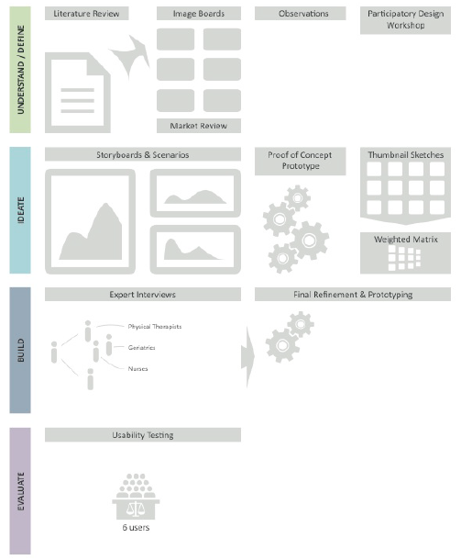

Timeline
Insert here a visual timeline of your thesis/project.

Example:

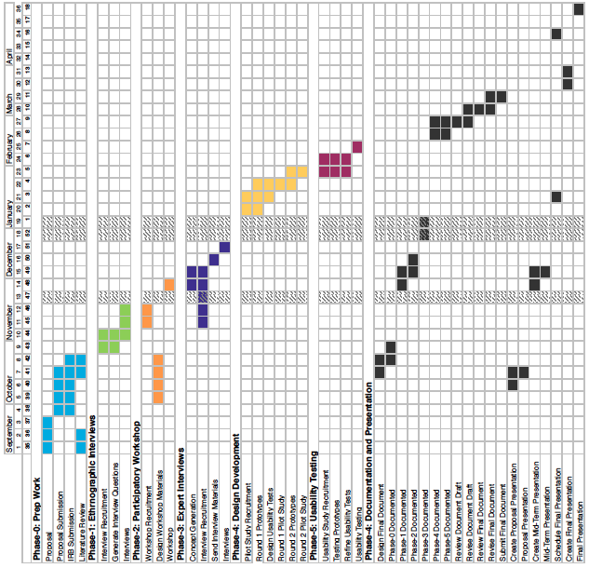

References
List all references used in this proposal following the APA 6th style (preferably).

Examples:

Book:
Author, A. A. (Year of publication). Title of work: Capital letter also for subtitle. Location: Publisher.

Journal Articles/Periodicals:
Author, A. A., Author, B. B., & Author, C. C. (Year). Title of article. Title of Periodical, volume number(issue number), pages. doi:http://dx.doi.org/xx.xxx/yyyyy

Website:
Author, A. A., & Author, B. B. (Date of publication). Title of document. Retrieved from http://Web address

Citation details:
http://owl.english.purdue.edu/owl/resource/560/1/

